2017-18 SSCS
SCIENCE OLYMPIAD INVITATIONALS

MICROBE MISSION
ANSWER KEY

Part I: Fill in the blank- write the correct word/phrase on your answer sheet
- Proteins
- Light compound microscope

  - Purple
  - Peptidoglycan
  - Red
- Upper right

  - Photoautotrophic
  - Chemoautotrophic

  - Lag phase
  - Exponential growth phase
  - Stationary phase
  - Death phase
- Stereo microscopes

  - Proteobacteria
  - Cyanobacteria
- Golgi apparatus

  - Object magnification
  - Ocular magnification

  - DNA
  - Cytoplasm
  - Cell membrane
  - Ribosomes

  - Fungi
  - Cellulose

  - Bacteriophages
  - Virophages

  - Coccus
  - Bacillus
  - Spirillum

  - Lytic
  - Lysogenic
- Bacteria

  - Streptococcus
  - Staphylococcus
  - Positive
- Pasteurization
- Prokaryotes
- Vectors

Part II: Diseases- write the corresponding letter on your answer sheet
B= bacterial V= viral F= fungal P=protozoan

- V
- B
- V
- B
- F
- P
- F
- V
- B
- P
- F
- V
- B
- V
- B

Part III: Labeling- write the correct part of the microscope and its function on your answer sheet
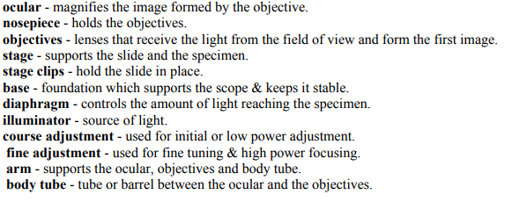
7
2
3
9
4
12
5
6
10
11
8
1

