Water Quality
By: silentsage
Section 1: Ecology (1pt. ea. for multiple choice, 2 for word problems)
- Biotic factors:
  - Rock, Tree, Fish
  - Fish, Insect, Algae
  - Cow, Rock, Human
  - Plant, Grass, Water
- Commensalism:
  - Barnacles on a whale
  - Algae eaten by scrapers
  - A lonely nekton
  - Cow eating grass
- Smallest ecological unit:
  - Community
  - Ecosystem
  - Individual
  - Biosphere
- Interacting Biotic and Abiotic factors in a region:
  - Ecosystem
  - Habitat
  - Biome
  - Niche
- The progression of pollution through an ecosystem is _________________
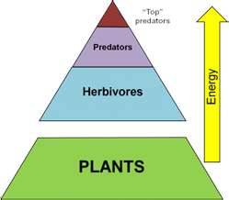
- In Fig. 1, if the plants contain 12, 420 J of energy, how much of that energy is contained within the predators? (to the nearest tenth)

- In Fig. 1, if the predators were to be removed, what would happen to the population of the plants?

- What is the trophic level of each organism?

Top predators-
Fig. 1
Predators-
Herbivores-
Plants-
Section 2: Macroinvertebrates (2pts. ea. For identification, 1 for class)
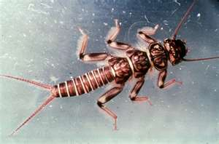
1.

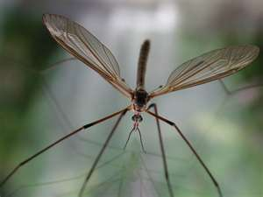
2.

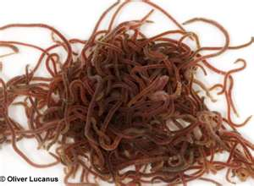
3.

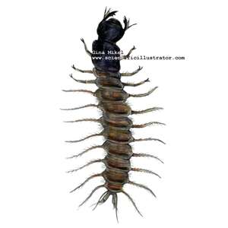
4.

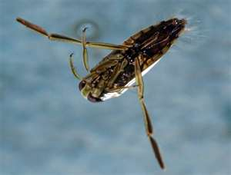
5.

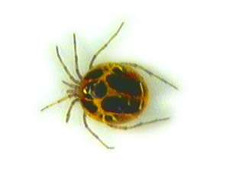
6.

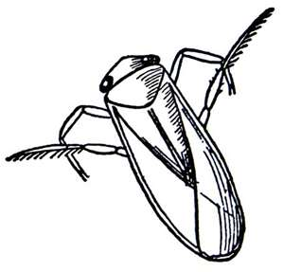
7.

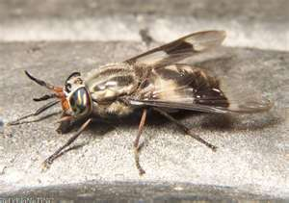
8.

Section 3: Analysis (1 pt. ea)
- DO is dangerous at over what percentage?

- What disease common in infants is caused by excess nitrates?

- What does fecal coliform indicate in water?

- What sewage treatment involves sludge tanks and anaerobic digestion?

- ph is what?

- What temperature has a higher oxygen concentration: 18 degrees C or 6 degrees C

- Nitrates and Phosphates cause what aging process in water environments?

- Water is densest at what temperature?

- Total dissolved solids affect what measurement of visibility?

- What is the unit that the above (answer to 9) is measured in?

- What is the weighing factor of DO?

- Alkalinity is the conversion of what substance into toxic forms?

- Salt concentrations are measured in what unit?

- Water Quality standards are set by what governmental entity?

- BOD stands for what?

