Name: _____________________________
School: _____________________________
Team Number: _____________________________

2017-18 SSCS
SCIENCE OLYMPIAD INVITATIONALS

MICROBE MISSION TEST

Part I: Fill in the blank- write the correct word/phrase on your answer sheet
- Prions are infectious __________ that are responsible for a class of diseases known as the Transmissible Spongiform Encephalopathies.
- The ___________ is the most commonly used microscope.
- Gram-positive bacteria are stained __________ and have a thick wall of __________. Gram-negative bacteria are stained __________.
- An organism viewed under a microscope appears to be moving to the lower left. The organism is actually moving to the __________.
- Bacteria may be __________, where they utilize photosynthesis to produce food and oxygen. They may also be __________, where they make food using the energy from chemical reactions.
- The four phases of a microbial growth curve are__________, __________, __________, and __________.
- __________ microscopes provide 3-D views of the specimen and are highly useful in observing opaque objects.
- The endosymbiotic theory holds that mitochondria and chloroplasts in eukaryotic cells originated specifically from __________ and __________, respectively.
- In a cell, the __________ is responsible for the final modification of proteins and packing them into vesicles to be secreted.
- To calculate the total magnification under a microscope, you should multiply the __________ by the ___________.
- The organelles that are present in both eukaryotes and prokaryotes are the __________, __________, __________, and __________.
- __________ have cell walls composed of chitin, while plants have cell walls composed of ___________.
- __________ are viruses that infect bacteria, and ___________ are viruses that infect other viruses.
- Bacteria come in three shapes: __________, __________, and __________.
- The two types of infections that viruses can cause are __________ and __________.
- This type of microbe is capable of nitrogen fixation: __________.
- __________ bacteria are found in chains and __________ bacteria found in grape-like clusters. Both are gram-__________ bacteria.
- __________ is a process that kills microbes in foods and liquids- such as milk- by heating them to specific temperatures.
- Between viruses, proteins, eukaryotes, and prokaryotes, __________ are the second largest in size.
- ___________ are living organisms that can transmit infectious diseases.

Part II: Diseases- write the corresponding letter on your answer sheet
B= bacterial V= viral F= fungal P=protozoan

- Measles - _________
- Cholera - _________
- Norovirus- _________
- Anthrax- _________
- Athlete’s foot- _________
- Giardiasis- _________
- Thrush- _________
- Polio- _________
- Strep throat- _________
- Malaria- _________
- Histoplasmosis- _________
- Yellow Fever- _________
- Pertussis- _________
- Zika- _________
- MRSA- _________

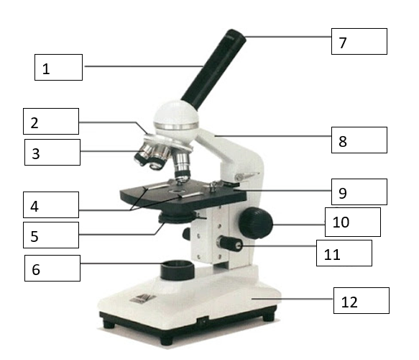
Part III: Labeling- write the correct part of the microscope and its function on your answer sheet

