DYNAMIC PLANET QUIZ FEB 18TH 2012
Station 1
. A temporary body of water formed in a meander cut-off is what type of lake?
Hoodoo
Oxbow
Yazoo
Overwash

2. This type of stream flows parallel to another, unable to join due to the natural levees caused by the larger river.
Ogive
Mere
Yazoo
Tidal

3. The sequence of shallow-deep-shallow or wide-narrow-wide channel pattern associated with most streams is called what?
Deep-Shallow Sequence
Curve-Straight Sequence
Bowl-Ripple Sequence
Pool-Riffle Sequence

4. A wadi is an Arabic term for what?
Intermittent Stream
Meander
Floodplain
Waterfall

5. An anastomosing channel is another name for what type of river?
Intermittent
Straight
Braided
Meandering

6. Due to its shape, the Mississippi delta is known as what type of delta?
Tidal
Pluvial
Estuarine
Birds Foot

7. During the last ice age there were great rivers flowing beneath the ice caps. As the ice melted, these landforms were left on the land surface where the rivers once flowed.
Dykes
Moulins
Eskers
Kaolins

8. Over time, a meandering channel migrates, both downstream and from side-to-side. This process is known as what?
Meander Refraction
Pneumatolysis
Lateral Accretion
Stretching

9. When a river floods, it deposits fine sediments on the floodplain. These sediments are called what?
Sinters
Lateral Accretions
Overbank deposits
Turbidity Layers

10. One of the choices below is a structure used to monitor the flow of a river or stream.
Dam
Hydrograph
Tor
Weir
STATION 2:
1. What is the longest river in Africa? ____________________________
2. What is the longest river in South America? ____________________________
3. What continent has no rivers? ___________________________________
4. What is the name of the beginning of a river? _______________________________
5. What is the name of a river or stream that flows into a larger river? _______________________________
6. What is the name of a stagnant lake that forms alongside a river after the river changes course? _______________________________
7. What is the name of the end of a river, where it empties into a large body of water? _______________________________
8. River deltas usually have what shape? _______________________________
9. What is the name of the area where a river meets the sea or ocean? _______________________________
10. What is the name of the natural cycle in which water travels from the earth to the atmosphere and back again? _______________________________
STATION 3:

- What is the name of the point where a river starts?

- What is the name of the point where a river ends?

- What is the name of an area of highland surrounding a river basin?

- What is the name of the point where two rivers meet?

- In the natural environment, water flows in a ________?

- The main human cause of flooding in Bangladesh is ______

- How can flooding in Bangladesh be reduced?

- Any moisture falling from the atmosphere is known as what?

- When trees and buildings stop rain from reaching the ground this is known what?

- When water returns to the atmosphere from lakes and rivers this is called?

STATION 4
IDENTIFY THESE BELOW PICTURES AND LABEL THEM …………….

1. 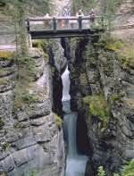

2. 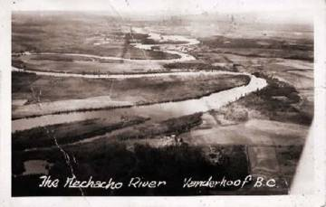 3.

STATION 5:
1. Backward rotation of a mass of earth material when mobilized is typical of
slides
slumps
rock fall
creep
2. Another term that describes chemical weathering is
disintegration
decomposition
rotting
fragmentation
3. Curved tree trunks, fractured retaining walls, curved roots are typical features of
slides
slumps
rock fall
creep
4. Talus is a deposit associated with
slides
slumps
rock fall
creep
5. Physical weathering
is typical of warm and wet environments
results in new mineral products being formed
increases surface area
all the above
6. Solifluction is a mass movement process in
the rain forest
the desert
the tundra
the steppe
7. _______ erosion occurs when water is confined to small channels.
rain splash
sheet
rill
gully
8. Sheet erosion
occurs as channeled flow
in some cases is nearly imperceptible
occurs when the infiltration capacity of the soil exceeds the rainfall intensity
all the above
9. Karst landscapes develop over _________ bedrock
sandstone
limestone
granite
basalt
10. Conditions favorable for mudflows include
unconsolidated surface materials
steep slopes abundant but intermittent precipitation
sparse cover of vegetation
all the above

STATION 6:
Map Reading Activity: Topography | Geography Pages
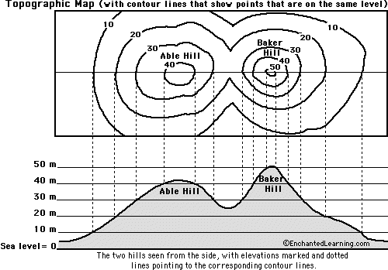

1. Color the elevations on the topographic map as follows. Red: 50m and higher, Orange: 40-50m, Yellow: 30-40m, Light green: 20-30m, Dark green: 10-20m, Purple: 0-10m.

2. Approximately how tall is Able Hill? | ___________________________

3. Approximately how tall is Baker Hill? | ___________________________

4. Which mountain is taller, and by about how much? | ___________________________

5. How many meters of elevation are there between contour lines on the topographic map? | ___________________________

6. Which mountain has steeper slopes? | ___________________________

7. Are the contour lines closer together on Able Hill or Baker Hill? | ___________________________
SECOND PART OF STATION 6:
Map Reading Activity: Topography #2 | Geography Pages
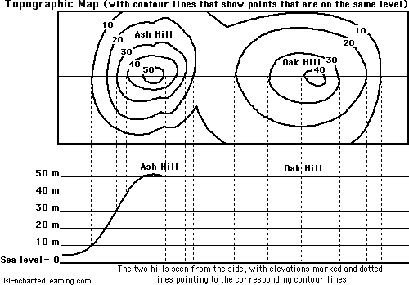

1. Color the elevations on the topographic map as follows. Red: 50m and higher, Orange: 40-50m, Yellow: 30-40m, Light green: 20-30m, Dark green: 10-20m, Purple: 0-10m.

2. Finish the mountain diagram below the topographic map, completing Oak Hill and drawing Ash Hill with proper elevations.

3. Approximately how tall is Ash Hill? | ___________________________

4. Approximately how tall is Oak Hill? | ___________________________

5. Which mountain is taller? | ___________________________

6. How many meters of elevation are there between contour lines on the topographic map? | ___________________________

7. Are the contour lines closer together on Ash Hill or Oak Hill? | ___________________________

8. Which mountain has steeper slopes?
STATION 7

Porosity is:
Need a Hint?
 |  |  | A) | the percentage of a rock's volume that is open space.
 |  |  | B) | the capacity of a rock to transmit fluid.
 |  |  | C) | the ability of a sediment to retard water.
 |  |  | D) | none of the above.
2 |  |  | Permeability is:  Need a Hint?
 |  |  | A) | The percentage of a rock's volume that is openings.
 |  |  | B) | the capacity of a rock to transmit fluids.
 |  |  | C) | the ability of a sediment to retard water.
 |  |  | D) | none of the above.
3 |  |  | The near-surface zone where all pores are filled with water is called:  Need a Hint?
 |  |  | A) | the saturated zone.
 |  |  | B) | the vadose zone.
 |  |  | C) | the water table.
 |  |  | D) | the aquifer.
4 |  |  | An aquifer is:  Need a Hint?
 |  |  | A) | a body of saturated rock or sediment through which water can move easily.
 |  |  | B) | a body of rock that retards flow of ground water.
 |  |  | C) | a body of rock that is impermeable.
 |  |  | D) | a body of rock containing water.
5 |  |  | Which rock would most likely form an aquifer?  Need a Hint?
 |  |  | A) | shale.
 |  |  | B) | granite.
 |  |  | C) | siltsone.
 |  |  | D) | sandstone.
6 |  |  | Why would the rock type above make a good aquifer?  Need a Hint?
 |  |  | A) | It has abudant porosity.
 |  |  | B) | It is often quite permeable
 |  |  | C) | It has abudant porosity and is often quite permeable.
 |  |  | D) | It is strong, so wells drilled into it don't collapse.
7 |  |  | Which rock type below is likely to possess the highest porosity?
 |  |  | A) | sandstone.
 |  |  | B) | conglomerate.
 |  |  | C) | siltsone.
 |  |  | D) | shale.
8 |  |  | Which rock type below is likely to possess the highest permeability?
 |  |  | A) | shale.
 |  |  | B) | sandstone.
 |  |  | C) | siltsone.
 |  |  | D) | granite.
9 |  |  | Which of the following determines how quickly groundwater flows?  Need a Hint?
 |  |  | A) | elevation.
 |  |  | B) | permeability.
 |  |  | C) | water pressure.
 |  |  | D) | all of these are important determinants of groundwater flow.
10 |  |  | Groundwater flows:
 |  |  | A) | always downhill.
 |  |  | B) | from high elevation to low elevation.
 |  |  | C) | from areas of high permeability to areas of low permeability.
 |  |  | D) | from areas of high hydraulic head to areas of low hydraulic head.
11 |  |  | The decline in the level of the water table around a pumping well is known as:
 |  |  | A) | the porosity parameter.
 |  |  | B) | the permeability gradient.
 |  |  | C) | the cone of depression.
 |  |  | D) | the sphere of influence.
12 |  |  | Prolonged withdrawal of water from an aquifer:
 |  |  | A) | may deplete the aquifer.
 |  |  | B) | can cause subsidence of the land surface.
 |  |  | C) | can alter the porosity or permeability of the aquifer.
 |  |  | D) | all of these.
13 |  |  | The largest reservoir of water on Earth is:  Need a Hint?
 |  |  | A) | the ocean.
 |  |  | B) | polar ice caps.
 |  |  | C) | groundwater.
 |  |  | D) | water vapor in the atmosphere.
14 |  |  | The top of the water saturated zone is known as:  Need a Hint?
 |  |  | A) | the aquitard.
 |  |  | B) | the aquifer.
 |  |  | C) | the hydraulic head.
 |  |  | D) | the water table.
15 |  |  | Ground water is:  Need a Hint?
 |  |  | A) | precipitation that accumulates underground.
 |  |  | B) | water from magmatic sources that accumulates underground.
 |  |  | C) | water that has always been underground.
 |  |  | D) | water the leaks into the ground from lakes, rivers, and reservoirs.
16 |  |  | An artesian well is one:  Need a Hint?
 |  |  | A) | where a cone of depression develops around the well when pumped.
 |  |  | B) | located in the city of Artesia, California.
 |  |  | C) | that flows to the surface without pumping.
 |  |  | D) | that is developed in an aquitard.
17 |  |  | Geysers and hot springs:  Need a Hint?
 |  |  | A) | are caused by groundwater being geothermally heated.
 |  |  | B) | are "Volcanoes of water".
 |  |  | C) | are common throughout the world.
 |  |  | D) | are always at very high temperatures.
18 |  |  | Caves and cavern systems are formed by:  Need a Hint?
 |  |  | A) | evacuation of magma chambers during volcanic eruptions.
 |  |  | B) | water moving through aquifers.
 |  |  | C) | removal of water from aquifers.
 |  |  | D) | groundwater dissolving limestone and dolomite.
19 |  |  | What proportion of Earth's water resources occurs as ground water?  Need a Hint?
 |  |  | A) | less than 1%.
 |  |  | B) | 10%
 |  |  | C) | 25%
 |  |  | D) | 33%
20 |  |  | Gaining streams are those where:  Need a Hint?
 |  |  | A) | water from the vadose zone flows into the stream.
 |  |  | B) | water is lost from the stream to the vadose zone.
 |  |  | C) | water from the saturated zone flows into the stream.
 |  |  | D) | water is lost from the stream to the saturated zone.

